Title of your contribution [Arial, bold, 14 point] line
A.B. Alpha¹, C.D. Beta², … [Arial, 11 point, centering]
E.F. Gamma¹ …[presenting author should be underlined]
¹Affiliation1, Address, Country
²Affiliation2, Address, Country [Arial, 11 point, Italic 12 point, centering]
E-mail: xxxx@xxx [Email address of corresponding author]

Abstract

The main text of Abstract should be typed in Ariel 11 pt in a two columns format. Please limit size to <1 page including any pictures and references). Total file size should not exceed 6 Mb.
The abstract should include a title (Arial, bold, 14 pt) followed by the authors, their affiliations, and the e-mail address of the corresponding author(s) are provided (Arial 11 pt, authors in plain font, affiliations in italic). The presenting author should be underlined. (The presenting author must register for the conference and present the paper by him/herself.
We accept only electronic .doc or .docx files uploaded in the BioBrillouin website.
The abstract file name should be the name of the presenting author, his institution and country (i.e. Alpha_XUniversity_Portugal).
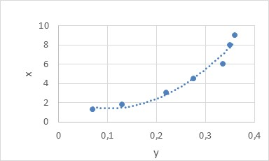
Figure 1. Graphic.
[1] K. Kappa and L. Lambda, Name. of. J. XX, yyyy (zzzz).

Please fill the next page with the requested information.

Please indicate ONE or TWO TOPICS in the Table below to classify your abstract
(this will be useful to schedule your contribution in the proper thematic session):

BioBrillouin
Topics coincide with the working groups of the BioBrillouin Cost Action. More information on what these entail can be found at: www.biobrillouin.eu
[ ] Medical & Clinical Applications
[ ] Phenotyping & Novel Applications in the Life Sciences
[ ] Instrument Design & Data Analysis

[ ] Correlative & Comparative Methods

[ ] Outreach & Dissemination

[ ] Other:_________________

Please indicate the preferred presentation type:

[ ] Oral [ ] Poster

The Cost Action “BioBrillouin” provides financial support for up to 50 members of the network, who will be selected based on the scientific quality of their contribution and the EU COST guidelines (notification will be provided by email within June 28th).

Are you a member of the COST Action and do you want to claim financial support?

[ ] YES [ ] NO

